Download Adding_A_Filter.pbix from Canvas and open the file. Your report view should look like the image below. Also, close any other open reports as this will speed up the processing of the currently opened Power BI file.

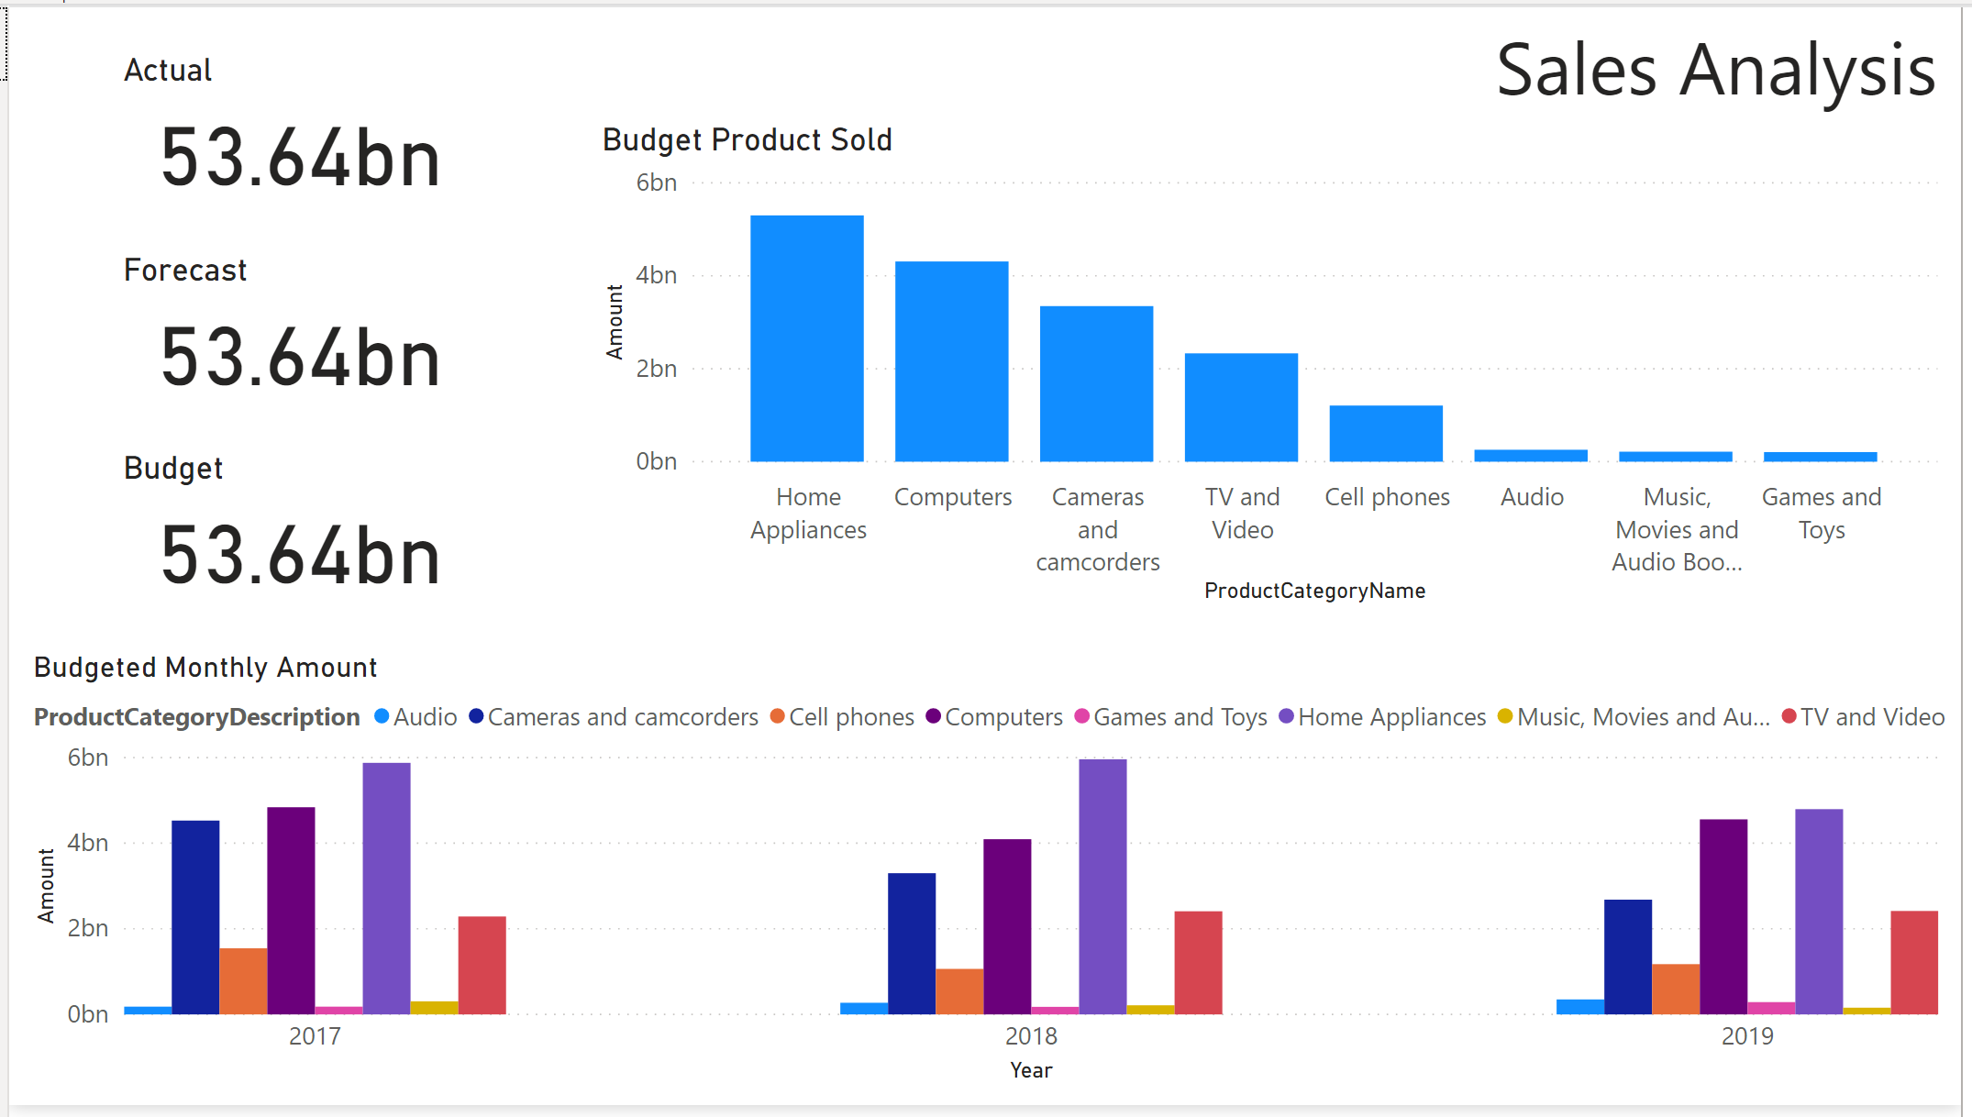

#### Adding a filter - Filtering is an important tool when you are creating Power BI reports. You do not always want to look at all of the data. Limiting the data used in visuals to only a selection that is relevant can help you answer more detailed business questions.

#### In the report, you can see that the cards on the Sales Analysis page tab are labeled Actual, Forecast, and Budget, but they all have the same values. You will need to apply some filters to fix this.

* Open the *Filters* pane. You can do this by clicking on the less-than sign icon.

#### 



#### Filter pane is now opened.

#### 

* Add a filter to the "Actual" card visual that filters on rows where ScenarioName is equal to Actual. You do this by first highlighting the card for “Actual”

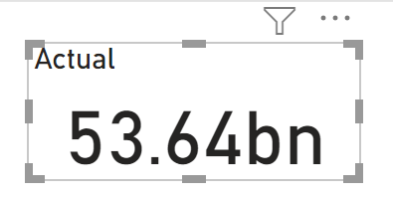

Find ScenarioName field from DimScenario table, and drag ScenarioName to Add data fields here (under the Filters on this visual section).

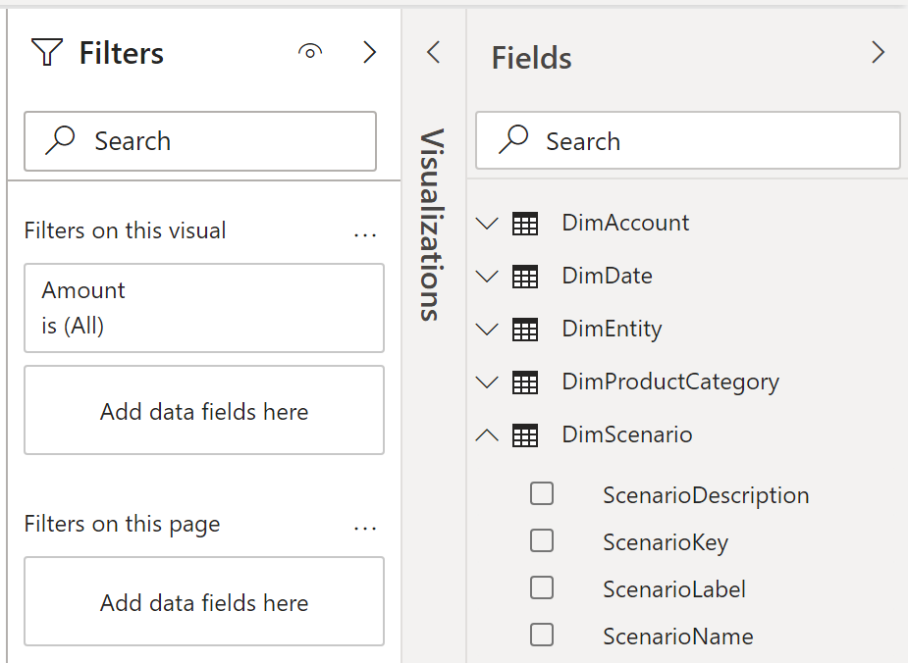



Note: In my personal experience, I find Filters on this page more profound than Filters on this visual. Try it!

Your filter will now look like the image below.

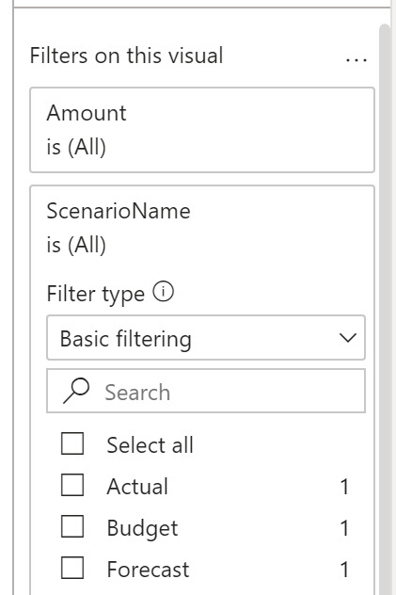



Check the Actual selection box and note how the card for “Actual” value has changed.

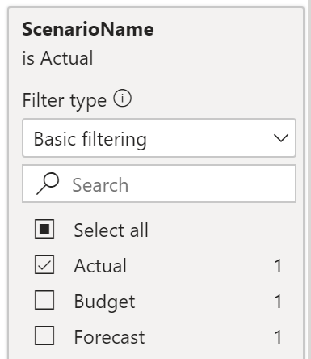 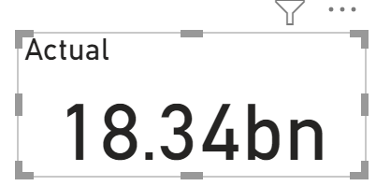

Add a filter to the "Forecast" card visual that filters on rows where ScenarioName is equal to Forecast. Using the same process, highlight the card for Forecast > find ScenarioName field from DimScenario table > and drag ScenarioName to Add data fields here (under the Filters on this visual section). Check the Forecast selection box and note how the card for “Forecast” value changed.

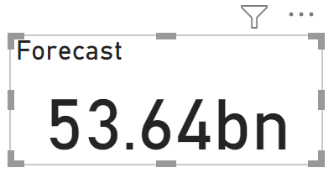 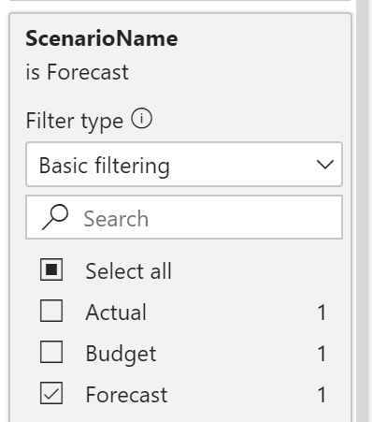 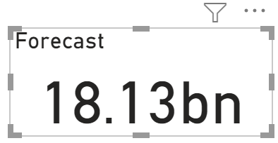



* Add a filter to the "Budget" card visual that filters on rows where ScenarioName is equal to Budget. Once again, using the same process, highlight the card for Budget, find ScenarioName field from DimScenario table, and drag ScenarioName to Add data fields here (under the Filters on this visual section). Check the Budget selection box and note how the card for “Budget” value changed.

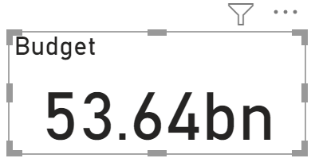 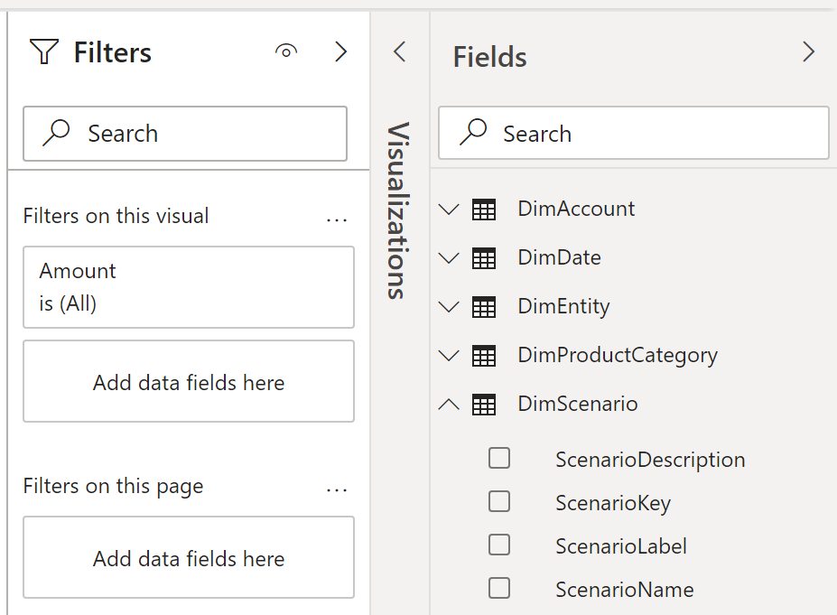



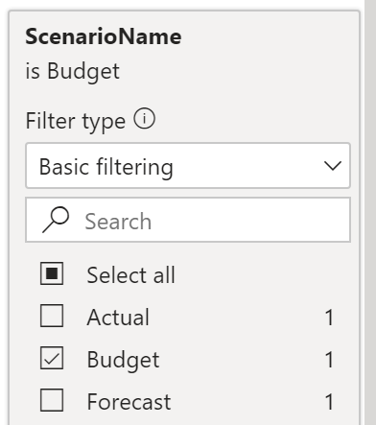 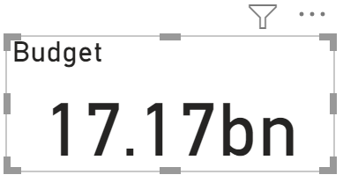

**What was the total forecasted amount?**

|  |
| --- |
| 18.13bn |

Please reposition your Report so that it would look like the dashboard below. Take a snapshot using Window's Snipping Tool. Make sure the encircled items are included. Place your image at the end of this document (after the example below) and submit this completed artifact to Canvas in Word format.  Please do not forget to save your work. Thank you for your diligence!

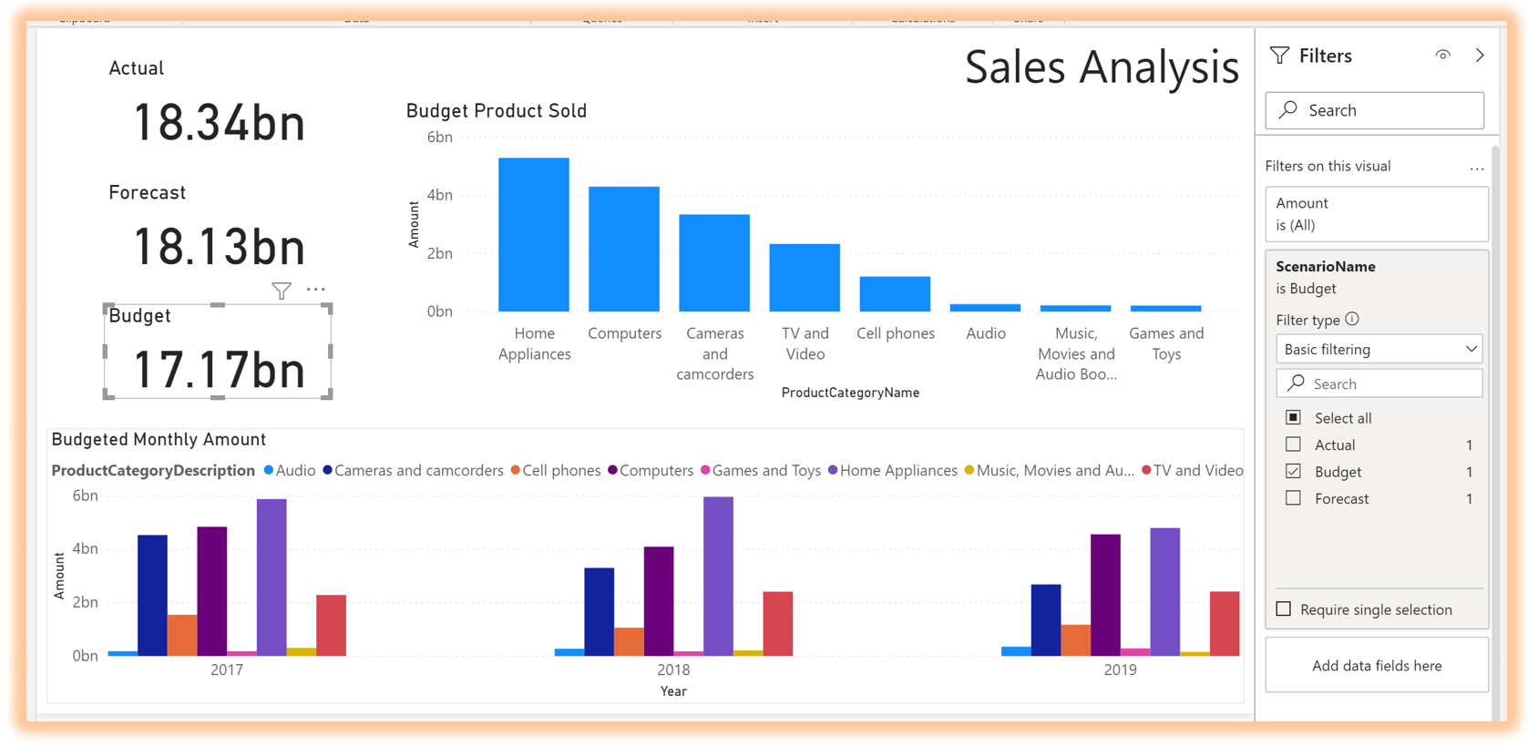



|  |
| --- |
| Please paste here your final dashboard. |